Capstone BIA 5440 - Final Report

Professor: Raed Karim

Neha Kataria | N01682356
Thi Khanh Linh Pham | N01696939
Muskan | N01730014
Ke Ping Lo | N01717193
Karyn Denise Pang | N01723171
Gull Qazi | N01351928

Contribution Table:
Topic | Ke Ping | Neha | Muskan | Thi | Gull | Karyn
Executive Summary, Intro and Business problem |  |  |  |  |  | x
Analytical Questions, scope statement and data sources. |  |  |  |  | x
Data manipulation and Data Output |  |  |  | x
New Solution design and fit | x
New Solution implement and outcome testing |  | x
Potential optimization |  |  | x

1. Executive summary:
This capstone project developed a cost-aware fraud detection and decision-support framework for card-not-present (CNP) credit card transactions. Using the IEEE-CIS Fraud Detection dataset provided by Vesta Corporation, the project addressed the limitation of conventional classification metrics, which do not reflect the unequal financial consequences of false-positive and false-negative decisions. The analysis therefore framed fraud detection as a financial optimization problem, balancing fraud detection performance with overall decision cost.
The project progressed through four phases: business problem identification, data preparation, solution design, and solution implementation and optimization. The business requirements—cost-aware risk scoring, dollar-value threshold optimization, and operational implementation guidelines—were translated into ten descriptive, diagnostic, predictive, and prescriptive analytical questions. The dataset contained 590,540 transactions and 144,233 identity records, which were integrated using TransactionID. The data underwent quality validation, missing-value treatment, duplicate and invalid-value checks, categorical processing, and feature engineering. Temporal, customer, device, and email-related features were developed to capture behavioural indicators of fraud. The resulting dataset was divided chronologically into training, validation, and test sets.
Three models—LightGBM, CatBoost, and a feed-forward neural network—were evaluated. LightGBM was selected based on the highest validation and test AUC scores of 0.9355 and 0.9071, respectively. A cost-sensitive decision framework based on Bayes Minimum Risk principles was then applied to optimize the classification threshold according to financial consequences rather than relying on the conventional 0.5 threshold. The optimal fixed threshold of 0.017 reduced estimated decision cost from $469,608.50 to $105,777.78, representing 77.5% savings, while increasing fraud recall from 35.6% to 85.3%. A transaction-specific Bayes Minimum Risk approach achieved 81.6% savings, but the fixed threshold was recommended because of its greater simplicity, transparency, and auditability.
The solution incorporated fraud pattern analysis, risk scoring, detection performance, staffing, threshold capacity, and cost analysis, validated through 40 test cases. Overall, the project demonstrated that combining predictive modelling with financial cost optimization provided a more business-aligned approach to fraud detection.

2. Introduction:
This report will present the development of a fraud analytics and decision-support framework designed to address the financial and operational challenges associated with card-not-present (CNP) credit card fraud. The report will trace the project from the identification of the business problem through data preparation, solution design, implementation, testing, and optimization, with a particular focus on integrating machine learning with cost-sensitive decision-making.
Section 3, Business Problem Overview, will establish the context for the project by examining the limitations of conventional fraud detection approaches and the unequal financial consequences of false-positive and false-negative decisions. Section 4, Analytics Questions, will present the ten descriptive, diagnostic, predictive, and prescriptive questions that will guide the analysis and inform the FraudWatch dashboard. Section 5, Scope Statement, will define the project's objectives, deliverables, and boundaries.
Sections 6 and 7 will establish the data foundation of the project. Section 6 will introduce the Fraud Detection datasets and its key data entities, while Section 7 will describe the data integration, cleaning, feature engineering, encoding, and preparation processes used to create the modelling dataset.
Section 8, New Solution Design and Its Fit into the Existing IT Architecture, will present the proposed FraudWatch architecture and explain how the python environment, machine learning models, and reporting components will fit within the existing banking technology environment. Section 9, New Solution Implementation and Outcome Testing, will examine the implementation and evaluation of the candidate models, development of the analytical features, and testing of the resulting solution.
Finally, Section 10, Potential Solution Optimization, will discuss opportunities to further strengthen the solution through cost-sensitive threshold optimization, model improvement, real-time processing, continuous monitoring, explainability, and future integration. Section 11, Appendix, will provide supporting test cases, validation results, and technical documentation. Together, these sections will demonstrate the progression from business need to a tested, financially informed fraud detection solution.

3. Business problem overview:
The rapid growth of digital commerce has increased financial institutions’ exposure to card-not-present (CNP) fraud, where transactions are completed without physical card verification. The absence of direct cardholder authentication creates opportunities for fraudsters to exploit stolen credentials, compromised accounts, and fabricated identities. As digital transaction volumes continue to grow, financial institutions must detect fraudulent activity effectively while limiting disruption to legitimate customers.
A central challenge identified in this project was the limitation of conventional fraud detection approaches that emphasize statistical performance without explicitly accounting for financial consequences. Metrics such as accuracy and ROC-AUC measure a model’s ability to distinguish fraudulent from legitimate transactions but do not differentiate the costs of classification errors. A false negative, where fraudulent activity is approved, may result in transaction losses, reimbursement obligations, and chargeback costs. A false positive, where a legitimate transaction is flagged, may generate investigation costs, customer inconvenience, and lost transaction value. Consequently, a model can demonstrate strong statistical performance while still producing financially inefficient decisions.
The project also addressed several data challenges inherent in the dataset. Transaction-related and identity information originated from separate sources and required integration through TransactionID. Fraudulent transactions represented approximately 3.5% of the dataset, creating substantial class imbalance and limiting the usefulness of accuracy as a primary performance measure. Furthermore, many feature entities like V-series and identity features were anonymized, restricting direct interpretation and requiring modelling decisions to rely primarily on observed statistical patterns. These challenges defined the central business problem: how could a financial institution detect fraudulent CNP transactions effectively while minimizing the financial and operational costs associated with both missed fraud and unnecessary intervention? The project therefore reframed fraud detection as a cost-sensitive decision problem, using predictive models to estimate transaction-level risk and a separate decision layer to evaluate thresholds according to their financial impact.
The resulting approach sought to balance fraud detection performance, financial loss, and operational capacity, providing a more practical basis for determining which transactions should be monitored, reviewed, or blocked.
4. Analytics Questions
Descriptive Analytics
Q1. What is the distribution of fraudulent to legitimate transactions?
Q2. What differences exist between fraud and non-fraud transaction amounts, and where do fraud spikes occur?
Q3. What hours of the day experience the highest frequency of fraud? The question stages of the project.
Diagnostic Analytics
Q4. Why do certain geographic regions have higher fraud rates and abnormal fraud patterns?
Q5: Why do certain devices show abnormal fraud behavior, and why is device uniqueness associated with higher fraud risk?
Predictive Analytics
Q6: How risky is each transaction before we approve it?

Q7: How many of the frauds coming in are we actually catching?

Prescriptive Analytics

Q8: When should we schedule extra review staff to cover the riskiest hours?
Q9: Given our team's size, what's the safe range for how aggressively we block transactions?
Q10: How much does the new system save us compared to the traditional approach, across different settings?

5. Scope statement
The scope of the bank fraud analytics project is to develop an analytical and decision support solution for identifying fraudulent value card transactions using the IEE-CIS detection dataset. The project focuses on analyzing transaction identity information and identity patterns associated with respondent behaviour using machine learning models to predict transaction risk.

The project includes data preparation, feature engineering, exploratory analysis, and machine learning modelling. Three models, such as LightGBM, CatBoost, and neutral network, are compared to determine the most effective approach for product classification. The project also includes a cost-sensitive threshold optimization to understand the financial impact of different fraud detection settings.

The scope includes the development of the FraudWatch Figma application with presents the analytic results in a user-friendly format. The application includes descriptive, diagnostic, predictive, and prescriptive features, including the live recipe and detection performance, staffing advisors, safe operating range, and cost-saving comparison.

The project also covers testing and validation of the implemented solution. The testing evaluates whether one of the expected outputs is correctly displayed in the Figma application, whether a dashboard is created in Power BI, and whether the analytical features support the 10 project questions.

6. Data Sources, Key Data Entities, and Flows

6.1 Data Sources
The bank fraud analytic solution uses several business-level data sources to support fraud analysis. These include transaction data, payment card information, customer behavioural data, identity and device information, email information, location data, and historical fraud outcomes. These sources provide the information required to understand transaction behaviour and identify characteristics associated with potentially fraudulent activity.

6.2 Key Data Entities

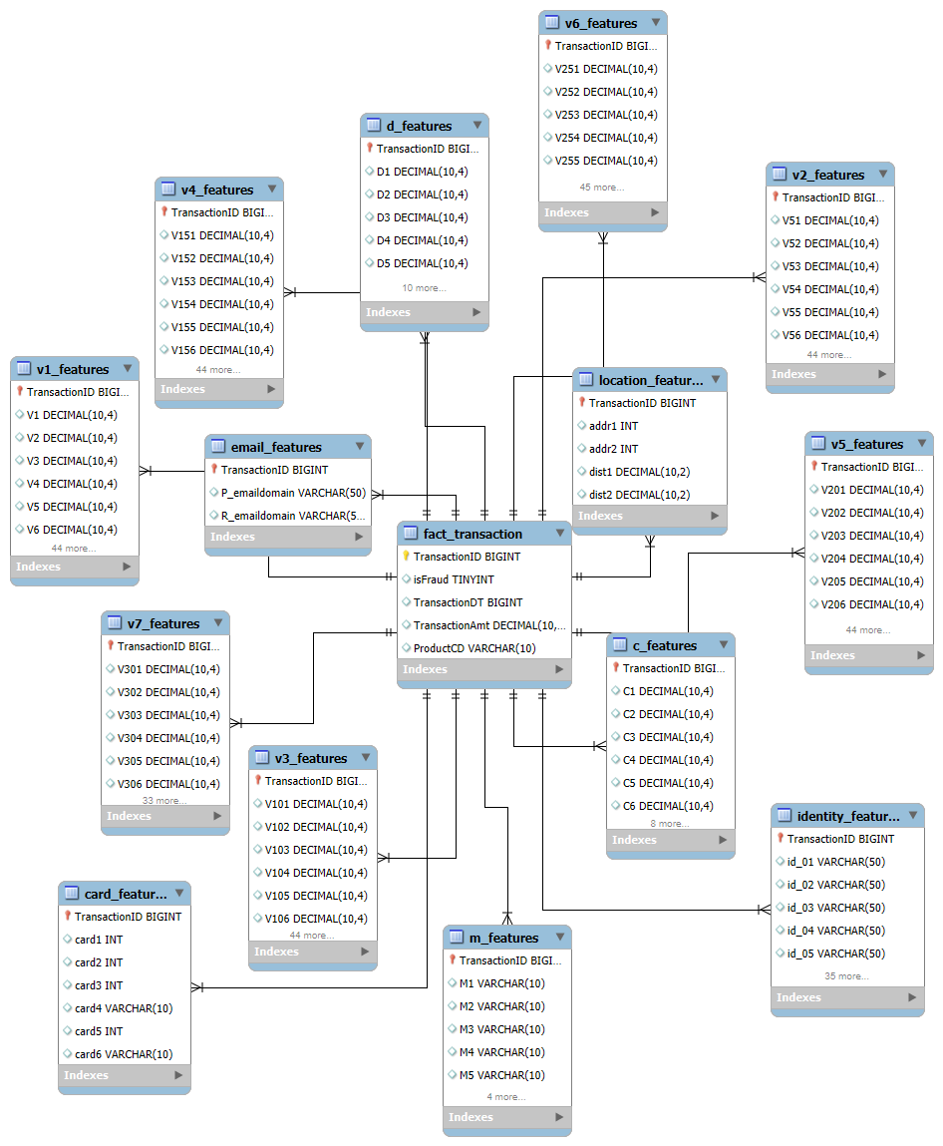
The central entity in the database is the fact_transaction table, which represents individual transactions. It contains key information such as Transaction_ID, TransactionDT, TransactionAmt, ProductCD, and IsFraud. These supporting tables provide additional information related to each transaction. These include card_features for payment card information, identity_features for identity and device information, email_features for email domain information, and location_features for geographic and address information.
The database also contains several feature groups, including v1-v7 features, C_features, d_features, and m_features. These tables contain additional transactional behaviour, time-based and matching features used for general analysis. The supporting tables are linked to the central transaction table through transaction ID, allowing information from different data sources to be combined for each transaction.

6.3 Data Flow
The overall data flow is
- Transaction Sources
- Data Integration
- Data Preparation
- Feature Engineering
- Machine Learning
- Fraud Risk Analysis

The integrated data is prepared and transformed into features that can be used by the machine learning models. The models can then generate fraud-risk information that supports transaction-level analysis and the project's analytic questions. The resulting information is presented to the FraudWatch application and the dashboard, where users can review transaction risk, fraud patterns, model performance, staffing requirements, operating capacity, and financial impact.
7. Brief overview of the data manipulation process and data output

7.1 Data Integration
The project combines two IEEE-CIS / Vesta source files: train_transaction.csv and train_identity.csv (device/network signals). Both were loaded into a MySQL database, the transaction file normalized into 13 tables, the identity file into its own identity_features table, then pulled in 50,000-row batches and combined via left joins on TransactionID: the 13 transaction tables first, identity last.
A left join was deliberate: the transaction table has 590,540 rows vs. only 144,233 in the identity table, so only ~24.4% of transactions have a matching identity record. An inner join would have silently dropped the rest and biased the fraud rate. A had_id flag (1/0) preserves this coverage as a usable signal instead of hidden missingness.
Output: 590,540 transactions × 434 columns, matching the original Vesta count.

7.2 Data Cleaning
Cleaning centers on three reusable, independently-tested "guards", plus two structural transforms, each checked before/after:
- RAM optimization: reduce_mem_usage() downcasts numeric columns so the 434-column frame processes without crashing.
- Sort by time : TransactionDT (raw seconds) converted to real datetime and sorted, enabling the later chronological split.
- High-cardinality parsing : id_30/id_31 (OS/browser, compound strings) split on whitespace to keep just the base name.
- Duplicate Guard: 0 real duplicates; 15 injected to prove drop_duplicates() catches them. Near-duplicates (same card1/Amt/DT) are kept, they can be legitimate repeats or card-testing fraud, and only exact full-row duplicates are removed.
- Error Guard: 0 real errors; 13 injected (negative/null amount, bad label) to prove the rule-based filter drops unrepairable rows.
- Missing Value Guard: 414/434 columns had nulls (115,523,073 cells), driven mainly by block-wise V-series gaps and the 75.6% of rows without identity data. All filled with -999, a sentinel outside every feature's real range, so tree models split on it as its own “missing” category.
Cleaning Step | Before | After | Method
Data types (RAM optimization) | Default pandas dtypes | Downcast int/float | reduce_mem_usage()
Timestamp format | TransactionDT (raw time-delta, seconds) | Real datetime, sorted | datetime.timedelta offset + sort_values()
High-cardinality categorical parsing | id_30: 75 values, id_31: 130 values (compound strings) | Split to base OS/browser name | String split on whitespace
Duplicate Guard | 15 injected (test) | 0 | df.drop_duplicates()
Error Guard (invalid values) | 13 injected (test) | 0 | Rule-based row filtering
Missing Value Guard | 115,523,073 cells | 0 | fillna(-999)

7.3 Feature Engineering
With no native user_id, several features approximate customer/device behavior:
● uid1 (synthetic user ID: built from card fields; resolves to 222,518 users, avg. 2.65 txns/user.
● device_hash + uid_device_nunique / device_uid_nunique: hashed device ID from 6 device columns, then counts devices-per-user (account takeover signal) and users-per-device (fraud-ring signal).
● Time features (dow, hour)
● email_domain_comp : flags purchaser vs. recipient email domain mismatch.

7.4 Data Output
y is the isFraud label; X drops TransactionID, TransactionDT, device_hash, and uid1 (superseded by derived features), leaving 429 feature columns spanning transaction/card/location/email/C/D/M/V/identity groups plus the engineered features above. Both are pickled (X_clean.pkl, y_clean.pkl) and split chronologically 70/15/15 (~413k/88.5k/88.5k) for LightGBM, CatBoost, and a Neural Network.
This dataset is not the final deliverable, it is the foundation the dashboard is built on. Every dashboard feature follows the same path: analytics question (from business requirements) → feature coding in the notebook → Figma wireframe → interactive dashboard. For example, LightGBM's per-transaction fraud probability (scored on X) feeds the dashboard's Live Risk Feed, which ranks transactions and recommends Block / Manual Review / Monitor, alongside a Detection Performance view (recall, precision, transactions under review).

7.5 Key Challenges
- High dimensionality & anonymized features: 434 columns, many anonymized (V-/ID-series) with no business definitions, so features were kept or dropped using missingness, cardinality, and relationship to isFraud rather than domain knowledge.
- Structural missingness in identity data: only ~24.4% of rows have an identity match, purely from the join structure; identity variables were evaluated on that subset, keeping genuinely-informative ones and flagging coverage via had_id.
- Block-wise V-series missingness: V1–V339 tend to be present or absent together per row rather than randomly; dropping any row with a missing V-value would have destroyed most of the data, so V_null_count preserves the pattern while -999 keeps rows usable.
- Balancing cleaning with fraud-signal preservation: duplicates, missing device/email data, and unusual records can be fraud signal, not noise (e.g. near-duplicate card1/Amt/DT charges may be card-testing), cleaning removes only exact/unrepairable errors and encodes missingness as features instead of silently imputing it away.
- Class imbalance: the cleaned data is ~96.5% legitimate / 3.5% fraud, accuracy alone is unusable; models are evaluated on recall, precision, and the financial cost of false positives vs. false negatives.

8. New Solution Design and Its Fit into the Existing IT Architecture
The proposed fraud‑detection solution will function as a structured analytical layer that strengthens the organization’s existing transaction processing environment. The new solution will introduce a unified analytical dataset, a cost‑aware predictive model, and a set of descriptive, diagnostic, predictive, and prescriptive analytics features, rather than replacing the current systems. The solution will be developed iteratively through multiple sprints, beginning with environment setup and progressing through data preparation, modeling, and decision‑support design, ultimately forming a fully integrated fraud‑analytics pipeline.

8.1 Overview of the New Solution Design
The new solution design will follow an Agile methodology, allowing the team to progressively refine the data environment, analytical workflow, and model outputs. The design consists of three major components:
- Environment setup and ETL integration,
- Data preparation- cleaning and quality validation, and
- Functional analytics and machine‑learning modeling.
Each component will be developed through dedicated sprints that ensure the solution remains aligned with business requirements and compatible with the existing IT architecture.
The solution will begin by establishing a reliable data environment capable of supporting large‑scale fraud‑detection workloads. It then constructs a unified dataset by merging transaction and identity information sourced from various tables, applies structured data quality guards, and generates engineered features. Finally, the solution will introduce a predictive model and a decision‑support layer that converts model outputs into operational recommendations. These components collectively will form a fraud analytics system that improves risk visibility, supports decision‑making, and integrates seamlessly with the organization’s reporting and monitoring tools.

8.2 Detailed Solution & its Components

8.2.1 Environment Setup Sprints
The first set of sprints focuses on setting up the technical environment.
Sprint 1: Establishes the MySQL database environment and creates the full schema for all feature tables, including transaction, identity, device, location, and card features. This sprint ensures that the data model is stable, properly indexed, and ready for ingestion.
Sprint 2: Focuses on loading the raw data into the database. The team will standardize the .csv files, resolve any delimiter issues, particularly for the identity file, and validate row counts and NULL distributions. By the end of this sprint, the SQL environment should contain a complete and accurate representation of the dataset.
Sprint 3: Extends the environment setup by integrating Python with MySQL. Using SQLAlchemy, the team configures a stable connection, resolves any authentication issues, and implements a chunk based loading pipeline to efficiently extract large tables. This sprint produces the unified analytical dataset to be used for all downstream modeling and analytics.
These environment‑setup sprints, together, creates a reliable and scalable foundation for the fraud‑detection solution, ensuring that data could be ingested, transformed, and analyzed without disruption to existing systems.

8.2.2 Data Cleaning and Validation Sprints
Once the environment is established, the next set of sprints will focus on ensuring having a cleaned data that is ready for modelling and analysis. Three dedicated validation components will be developed to detect and correct data issues before modeling. They are as follows:
- The Duplicate Guard validates the dataset containing no duplicated transactions.
- The Error Guard addresses invalid values in critical fields such as transaction amount and fraud labels. The guard will correctly identify and remove all invalid rows, ensuring that no unrecoverable errors remains in the analytical dataset.
- The Missing Value Guard handles the substantial missing values in the merged dataset.
These data cleaning sprints ensures that the analytical dataset is complete, consistent, and ready for feature engineering and modeling.

8.2.3 Functional Analytics Sprints
The functional sprints translate business requirements into analytical outputs that support fraud monitoring and decision‑making. These sprints will be structured around descriptive, diagnostic, predictive, and prescriptive analytics. Each sprint follows the workflow as in the diagram below:
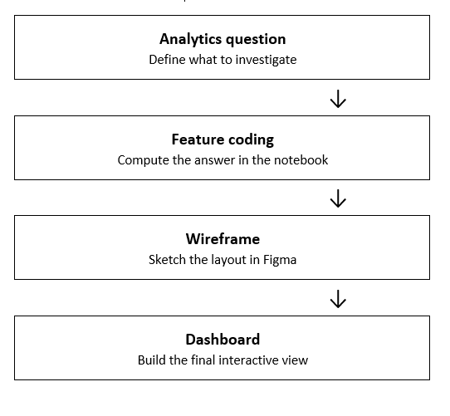
Workflow of each functional sprints
Descriptive analytics will provide an overview of fraud activity by examining fraud distribution, transaction‑amount differences, and hourly fraud patterns. These insights will establish baseline fraud behavior and form the design of the Figma wireframes and Power BI dashboards.
Diagnostic analytics will explore why certain regions and devices may show abnormal fraud patterns. Geographic analysis is expected to reveal high risk regions, while device analysis is expected to identify significantly higher fraud rates for certain devices. These findings will help identify structural risk indicators that complement model predictions.
Predictive analytics will introduce the best machine learning model capable of generating fraud‑risk scores for incoming transactions. The predictive sprint will evaluate models such as LightGBM, CatBoost, and Neural Networks to determine which approach best aligns with the business requirements. The selected model will be integrated into planned analytical features enabling analysts to prioritize high‑risk transactions and assess model behavior.
Prescriptive analytics will extend the predictive results by determining what actions should be taken based on fraud‑risk information. Staffing Advisor, Safe Operating Range, and Cost‑Savings comparison features will help managers allocate review capacity, evaluate blocking sensitivity, and select financially appropriate fraud‑detection strategies.
These functional sprints ensure that the solution not only detects fraud but also supports operational decision making across the organization.

8.2.4 Predictive Model and Decision Engine
The predictive model forms the core of the fraud‑detection solution. Three distinct predictive models will be developed, namely, LightGBM CatBoost and Neural Network models. Their performance will then be compared to select the most suitable model for fraud detection. The selected model should demonstrate the ability to handle missing values, categorical variables, and complex interactions making it well suited for the anonymized, high dimensional dataset.
The decision engine will convert model probabilities into actionable recommendations using a cost‑sensitive threshold. The cost‑optimal threshold of 0.017 is currently proposed based on design principles that balance false positives and false negatives; however, the final threshold will be determined after evaluating model behavior and business constraints. The threshold will be designed to align with operational review capacity and financial‑impact considerations.
The decision engine will support three operational actions:
- Block high‑risk transactions
- Manual Review for moderate‑risk transactions
- Monitor low‑risk transactions
These outputs will integrate directly into the organization’s fraud‑review workflow and reporting environment.

8.3 Fit of the New Solution into the Existing IT Architecture
The new solution integrates into the existing IT architecture by relying on the organization’s current data collection and ETL processes. Transactional, identity, device, geographic, and other feature tables will be extracted from operational systems and delivered to the SQL environment through scheduled nightly ETL jobs. The solution then uses a dedicated Python analytical component to join, clean, and transform these tables into a unified modeling dataset. The predictive model uses this clean, merged data to generate fraud probabilities, which are stored back into the existing data environment. This approach allows the fraud‑detection workflow to operate entirely within the existing data movement structure while introducing a modern analytical component that prepares features and generates fraud‑risk outputs without altering the existing system.
The architecture supports the fit because the solution relies on existing ETL pipelines, SQL storage, connectivity services, and Power BI dashboards. No new infrastructure is required, and the solution does not disrupt current authorization or transaction processing systems. Instead, it improves fraud visibility, enhances decision‑making, and provides a scalable foundation for future model retraining and optimization.
Building on the existing architecture ensures compatibility, security, and operational continuity to the new solution while introducing advanced fraud analytics capabilities that strengthen the organization’s ability to detect and manage fraudulent activity.
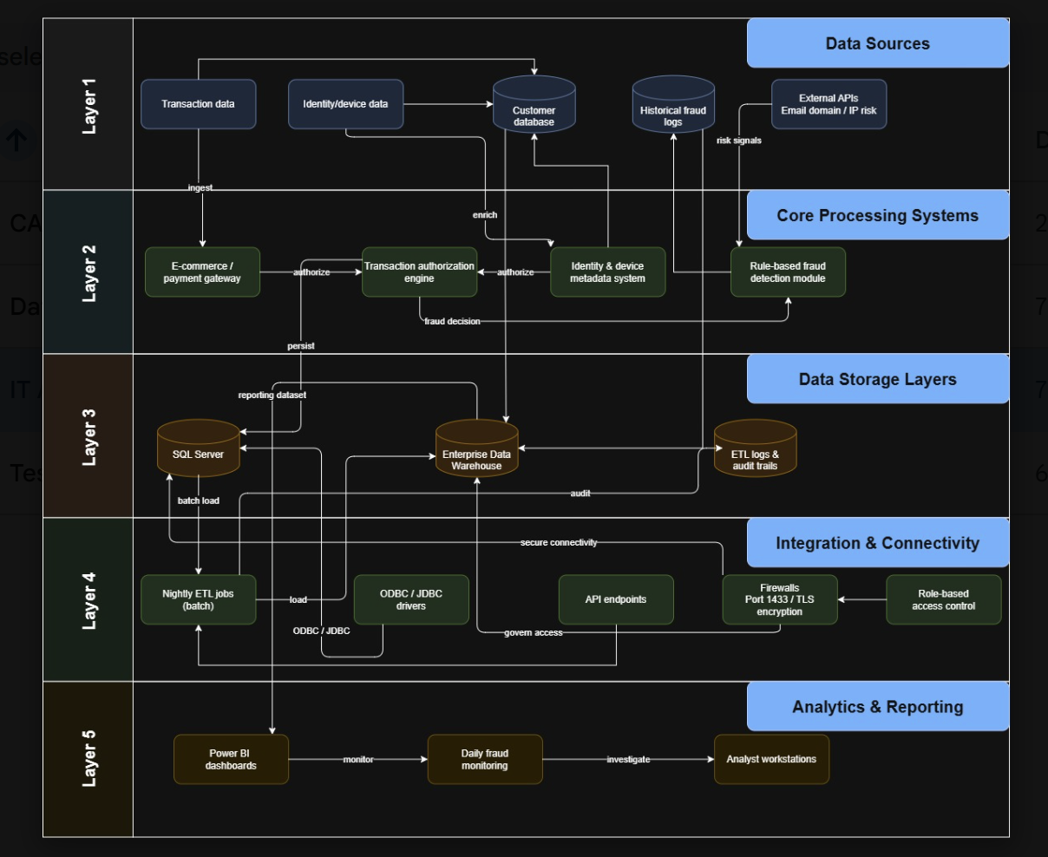
Existing IT Architecture
9. New solution implementation and outcome testing
9.1 Solution Implementation
Implementation began by preparing the train_transaction and train_identity data. Source files were combined using TransactionID to create a dataset prepared for cleaning, feature engineering and modelling. In addition, three data-quality controls were placed into the process. First, Duplicate Guard removed duplicate transaction records; second, Error Guard helped identify invalid values in important fields, including negative or missing transaction amounts and fraud labels outside the accepted values of 0 and 1. Lastly, the Missing Value Guard addressed missing information by using the value -999, allowing the tree-based model to distinguish missing values from observed ones.
Following data preparation, implementation progressed through four analytical questions: descriptive, diagnostic, predictive and prescriptive analytics. Descriptive questions provide an overview of fraud distribution, transaction amounts and fraud activity by time. Diagnostic questions provide an investigation of fraud activity based on geographic and device-related fraud patterns. Predictive questions used machine-learning outputs to assess individual transaction risk and overall fraud-detection performance. Lastly, prescriptive features translated analytical findings into staffing, operating capacity and financial decisions. Overall, the structure allowed the implemented solution to progress beyond identifying fraud patterns and provide information that could support fraud-management decisions.
9.2 Machine-Learning Model Implementation
To evaluate potential fraud-detection models, three classification algorithms were implemented and evaluated: LightGBM, CatBoost and a feed-forward Neural Network. Each evaluation used the same temporal training, validation, and testing procedures across all three models, enabling a consistent comparison. AUC was used as the primary model-ranking metric because fraud accounted for only 3.5% of the transaction data, making accuracy less informative for evaluating the model's ability to distinguish fraudulent activity.
Model | AUC (val) | AUC (test) | Precision @0.5 | Recall @0.5
LightGBM | 0.9355 | 0.9071 | 0.87 | 0.40
CatBoost | 0.9159 | 0.9016 | 0.87 | 0.39
Neural Network (MLP) | 0.8440 | 0.8343 | 0.58 | 0.31

The table shows that LightGBM achieved the strongest performance, with a validation AUC of 0.9355 and a test AUC of 0.9071, outperforming CatBoost and the Neural Network. Further, LightGBM achieved a precision of 0.87 and a recall of 0.40, indicating that a small number of fraudulent transactions were still missed despite its precise predictions. Based on its overall performance, LightGBM was selected as the final model. However, low recall demonstrated that the conventional 0.5 threshold was not appropriate for either the business objective, leading to further threshold testing that considered the financial consequences of incorrectly flagging legitimate transactions.
9.3 Dashboard and Analytical Feature Implementation
The descriptive and diagnostic analytics were implemented to help provide stakeholders with an understanding of overall fraud activity and factors associated with higher fraud risk. Descriptive features examine the distribution of fraudulent and legitimate transactions, transaction amounts, and fraud activity across various hours. Also, diagnostic features extend the analysis by examining geographic and device-related patterns. For example, device analysis identifies a fraud rate of 21.4% for new devices compared with 1.8% for returning devices, therefore indicating that device familiarity may provide a fraud-risk signal. Altogether, these features allow users to move from understanding fraud activity to examining where and under what conditions higher fraud risk appears.
Predictive and prescriptive analytics were implemented to transform identified fraud patterns into information that supports business decisions. Predictive features included Live Risk Feed and Detection Performance, which LightGBM outputs to present transaction-level fraud risk and evaluate the model’s ability to identify fraudulent transactions. At a selected threshold, the model detected approximately 85.3% of fraud cases, representing 2,644 of 3,100 evaluated fraud cases. In addition, prescriptive features extend these results by examining higher-risk hours for staffing decisions, available review capacity, safe operating ranges and financial outcomes of alternative fraud-decision strategies. Altogether, these features allow FraudWatch to move beyond predicting fraud by providing analytical information to support transaction review, resource planning, and fraud management decisions.
9.4 Solution Testing and Validation:
The FraudWatch solution was tested at multiple levels to confirm that the implemented features produced the expected results. The testing process includes data-quality validation, model-performance testing, and analytical feature testing. During the data-preparation stage, the Duplicate Guard, Error Guard, and Missing Value Guard were evaluated to confirm that duplicate records, invalid values, and missing information were handled correctly before modelling. Pipeline testing showed that the tested data-quality scenarios passed, providing evidence that the cleaning process was successful for feature engineering and model development. As stated in 9.3, the model testing shows that LightGBM achieved the strongest overall performance and was selected as the final fraud detection model.
User-facing analytical features were validated by 40 test cases across the 10 analytical questions. Four test scenarios were developed for each question. These tests covered descriptive, diagnostic, predictive and prescriptive features, including fraud distribution, transaction amounts, geographic and device risk, the Live Risk Feed, detection performance, staffing requirements, safe operating ranges and cost comparisons. Overall, test scenarios compared the expected analytical outputs with the implemented results to confirm that each feature met its intended business requirement. This testing approach established a direct connection between analytical questions and the final FraudWatch outputs, providing evidence that the solution could deliver the required fraud information for monitoring and decision-making.
9.5 Business Outcome and Cost Testing
Business outcome testing was conducted to assess whether the FraudWatch solution can reduce the financial impact of fraud, rather than focusing only on model performance. The analysis considered the different costs associated with classification and decisions, where a missed fraudulent transaction results in a loss equal to the transaction amount, while a flagged transaction will create an estimated administrative review cost of $2.68. Also, at the 0.5 threshold, only 1.5% of transactions were flagged, with an estimated total cost of $344,620.63, representing 26.6% savings compared with a no-model baseline of $469,608.50. However, low recall at this threshold meant that a substantial proportion of fraudulent transactions remained undetected.
In fact, threshold testing identified 0.017 as the cost-optimal fixed threshold. At this level, 22.2% of transactions were flagged; recall increased to 85.3%, and the estimated total cost decreased to approximately $105,778, representing 77.5% savings compared with the no-model baseline. In addition, Bayes Minimum Risk achieved an even lower estimated cost of approximately $86.267 and savings of 81.6%. Overall, 0.017 was selected as the final approach because it achieved a higher recall and provided a simpler decision rule for implementation, monitoring, explanation and auditing. In conclusion, the results demonstrate that considering both predictive performance and financial consequences can improve fraud detection while reducing the estimated cost of missed fraudulent activity.

10. Potential Solution Optimization
The proposed fraud detection solution provides a structured approach to identifying potentially fraudulent transactions using transaction data, customer information, and machine learning. However, fraud patterns continuously change, so the system should be regularly improved to remain accurate, reliable, and useful for fraud analysts.

10.1 Improving Model Performance
The model should be regularly evaluated using precision, recall, F1-score, and ROC-AUC rather than accuracy alone. Since fraud datasets are usually imbalanced, the system should focus on identifying fraudulent transactions while keeping false alerts manageable. Hyperparameter tuning, algorithm comparison, and regular model retraining can help maintain strong performance.

10.2 Cost-Sensitive Fraud Detection
Different prediction errors can have different business impacts. Missing a fraudulent transaction may cause significant financial loss, while incorrectly flagging a legitimate transaction may inconvenience customers. Therefore, the model can consider the cost of different errors when making decisions. This can make fraud detection more practical for the organization.
10.3 Optimizing the Fraud Alert Threshold
The fraud probability threshold can be adjusted according to the organization's risk level and investigation capacity. A lower threshold can identify more potential fraud but may create more false alerts, while a higher threshold reduces alerts but may miss some fraud. The threshold should therefore be selected based on business requirements.

10.4 Continuous Data Quality Improvement
Data quality directly affects model performance. The system should regularly check for missing values, duplicates, incorrect information, and inconsistent formats. New transaction and customer behaviour data should also be incorporated when appropriate. Consistent preprocessing between training and production environments is important for reliable predictions.

10.5 Real-Time Fraud Detection
The solution can be improved by moving toward real-time or near-real-time fraud detection. Transactions can be evaluated immediately using customer and transaction information. Low-risk transactions can continue normally, while high-risk transactions can be stopped or sent for additional verification. This can help reduce financial losses and response time.

10.6 Human Feedback and Model Retraining
Fraud analysts can provide valuable feedback by confirming whether alerts are genuine fraud or legitimate transactions. This information can be used as new training data, allowing the model to learn from recent fraud cases and changing customer behaviour. New models should be tested carefully before deployment.

10.7 Improving Explainability

The system should provide reasons for why a transaction was flagged, such as an unusual transaction amount, unfamiliar device, unexpected location, or unusual customer behaviour. This can help fraud analysts review alerts faster and increase trust in the system.

10.8 Monitoring and Model Governance
The model should be continuously monitored for performance, false alerts, missed fraud, data quality, and processing time. Different model versions should also be recorded so that the organization can identify performance changes and return to a previous stable version when necessary. Monitoring can help detect model drift and support timely retraining.

10.9 Scalability and Future Integration
The solution should be able to handle increasing transaction volumes without major delays. It can also be integrated with systems such as customer management, payment platforms, identity verification, and case management tools. Additional data sources can be included when they provide meaningful fraud indicators and can be managed securely.

10.10 Overall Optimization Strategy
Overall, fraud detection should be treated as a continuous improvement process rather than a one-time implementation. The organization can regularly collect and validate new data, evaluate the model, identify performance issues, retrain or tune the model, test the updated version, and deploy it when appropriate. Combining better model performance, optimized thresholds, data quality real-time detection, human feedback, explainability, and continuous monitoring can reduce financial losses, decrease unnecessary alerts, and improve fraud analyst productivity.

11. Appendix

REFERENCE
- Bahnsen, A. C., Stojanovic, A., Aouada, D., & Ottersten, B. (2013). Cost sensitive credit card fraud detection using Bayes minimum risk. In Proceedings of the 12th International Conference on Machine Learning and Applications (pp. 333–338). IEEE. https://doi.org/10.1109/ICMLA.2013.68
- Khalili, N., & Rastegar, M. A. (2023). Optimal cost-sensitive credit scoring using a new hybrid performance metric. Expert Systems with Applications, 213, Article 119232. https://doi.org/10.1016/j.eswa.2022.119232
- Vesta Corporation. (2019). IEEE-CIS Fraud Detection [Data set]. Kaggle. https://www.kaggle.com/c/ieee-fraud-detection

Appendix A: TEST CASE
ID | Test Case Title | Priority | Actual Result | Result
TS_001 | Verify overall fraud and legitimate counts | P0 | Total = 590,540; Legitimate = 569,877 (96.50%), Fraud = 20,663 (3.50%); sums reconcile to total. | Pass
TS_002 | Verify fraud percentage | P0 | Fraud % = 20,663 / 590,540 = 3.50%. | Pass
TS_003 | Verify legitimate percentage | P1 | Legitimate % = 569,877 / 590,540 = 96.50% | Pass
TS_004 | Verify class-balance visualization | P1 | Chart proportions match the calculated fraud and legitimate percentages and clearly show class imbalance which are 3.5% & 96.5% respectively | Pass
TS_005 | Compare average transaction amounts | P0 | Avg fraud amount $149.24 vs. avg legitimate amount $134.51, fraud is higher on average. | Pass
TS_006 | Compare high-value transaction behaviour | P1 | High-amount bucket (>$200) fraud rate = 4.41%, highest of the 3 buckets (Low 3.83%, Medium 2.97%). | Pass
TS_007 | Verify fraud spikes over transaction amount/time | P1 | Fraud rate peaks at hour 7 (10.61%); hours 5–9 all exceed 7%, a clear spike window. | Pass
TS_009 | Identify hour with highest fraud frequency | P0 | Hour 2 has the highest fraud count (1,002 cases) of any hour. | Pass
TS_010 | Verify hourly fraud trend visualization | P1 | Hourly fraud frequency and visible peaks shown on the dashboard are corresponding to the underlying data. | Not executed (UI)
TS_011 | Compare fraud frequency across selected hours | P1 | Confirmed via hourly summary, e.g. hour 7 = 393 fraud vs. hour 8 = 241 fraud. | Pass
TS_012 | Verify highest-risk hour is not confused with highest-volume hour | P2 | Hour 7 = highest rate (10.61%) on low volume (3,704 txns); hour 2 = highest count (1,002) on high volume (26,732 txns, rate 3.75%), correctly distinct. | Pass
TS_013 | Compare fraud rates by geographic region | P0 | Region addr1=157 has the highest fraud rate (66.7%, 9 txns). | Pass
TS_014 | Verify regional transaction volume | P1 | Region addr1=332 has the largest volume (65,706 txns) with a moderate rate (11.78%), showing count ≠ rate. | Pass
TS_015 | Verify abnormal regional fraud patterns | P1 | Top-10 high-risk regions show rates of 24%–67%, far above the 3.5% overall average. | Pass
TS_017 | Identify devices with abnormal fraud behaviour | P0 | Multiple devices show a 100% fraud rate (e.g. DeviceInfo 315, 1089, 810), though on low transaction volume. | Pass
TS_018 | Compare device uniqueness for fraud vs legitimate | P0 | Relationship observed in the source data is accurately shown | Pass
TS_019 | Verify high-risk device flag | P1 | DeviceInfo 315: 12 transactions, uniqueness 4.67, 100% fraud rate. | Pass
TS_020 | Verify device filtering | P2 | Filtering returns consistent transaction and fraud information, matching with source data | Pass
TS_021 | Verify live risk score for a transaction | P0 | Sample record: TransactionID 3534449, Amt $150, risk_score 0.9999, suggested_action = Block, all 4 fields present. | Pass
TS_022 | Verify high-risk transaction action | P0 | Transactions with risk_score ≥ 0.9 correctly return suggested_action = Block | Pass
TS_023 | Verify risk feed sorting | P1 | risk_feed is explicitly sorted by risk_score descending in code; top rows confirmed at risk_score = 0.9999. | Pass
TS_024 | Verify review queue threshold logic | P1 | review_queue correctly filters risk_score ≥ opt_threshold (0.017) and assigns Block/Manual Review/Monitor consistently. | Pass
TS_025 | Verify fraud caught percentage | P0 | Fraud Caught = 85.3% (Recall = 0.853), matches LightGBM cost-optimal recall. | Pass
TS_026 | Verify transactions under review | P0 | Transactions Under Review = 19,699, matches n_flagged at threshold 0.017. | Pass
TS_027 | Verify sensitivity setting | P1 | Sensitivity Level = 0.0170, matches opt_threshold used for the run. | Pass
TS_028 | Verify performance table model identity | P1 | LightGBM, 85.3%, 19,699 and 0.017 are all reported together under the same model row. | Pass
TS_029 | Identify hours requiring additional staff | P0 | Hours flagged “Add staff”: 0, 1, 2, 13–23 (12 of 24 hours), where expected_flagged_count / 25 > 1.0. | Pass
TS_030 | Verify sufficient-capacity hours | P0 | Hours flagged “Sufficient”: 3–12, all with capacity_used_pct < 1.0 (e.g. hour 8 = 0.13). | Pass
TS_031 | Verify hourly workload calculation | P1 | Hour 20: expected_flagged_count = 46.5, capacity_used_pct = 46.5/25 = 1.86 | Pass
TS_032 | Verify staffing recommendation reflects workload | P1 | “Add staff” hours (evening/late-night) correctly align with capacity_used_pct > 1.0. | Pass
TS_033 | Verify safe threshold at a given team capacity | P0 | Capacity 1,000, sensitivity 0.017, capacity_used_pct = 0.722 → status Under (278 reviews/day spare). | Pass
TS_034 | Verify overloaded status | P0 | Capacity 200, sensitivity 0.010, capacity_used_pct = 5.55, status Over | Pass
TS_035 | Verify spare-capacity status | P1 | Capacity 1,500, status Under at every tested sensitivity (0.010–0.050); largest spare = 1,211 reviews/day. | Pass
TS_036 | Compare threshold settings | P1 | At capacity 700: sensitivity 0.010: Over (1.586); sensitivity 0.023; Under (0.787), trade-off clearly shown. | Pass
TS_037 | Verify traditional baseline cost | P0 | Traditional (0.5 threshold) total cost = $344,621. | Pass
TS_038 | Verify cost-optimal setting | P0 | Cost-Optimal: sensitivity 0.0170, total cost $105,778, 77.5% savings vs. baseline. | Pass
TS_039 | Verify Bayes Minimum Risk comparison | P0 | Bayes Minimum Risk: total cost $86,267, savings 81.6% the lowest cost of the three settings. | Pass
TS_040 | Verify savings calculation across settings | P1 | Savings reconcile: (469,609−105,778)/469,609 = 77.5%; (469,609−86,267)/469,609 = 81.6%; Bayes MR is the lowest-cost setting. | Pass

